**Journal Report 28**

**04/12/24**

I spent the majority of the class wrapping up the coding for my FilteringAnomalyModel. I was able to get the Wasserstein to work and am now trying to put it into an illustrative format. Specifically, I want it to look similar to this graph but with an extra scorer graph below the KMeans scorer in order to show the difference between them.

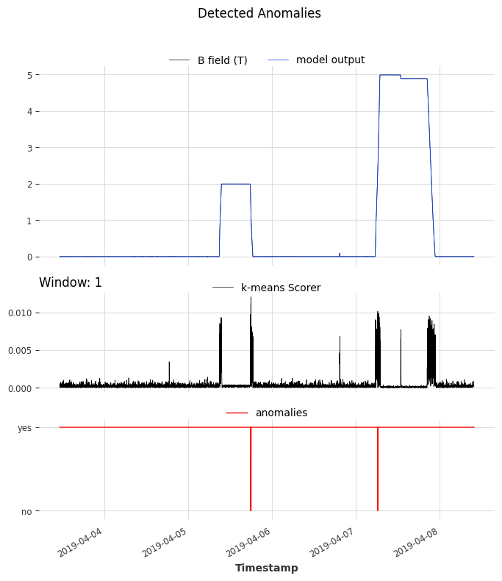

I hope to finish this in the coming week and two weeks at the latest.

**04/15/24**

I spent the majority of the class formatting my poster and collecting graphs. I am using Google Slides as my presentation editor and used Canva as a method to create diagrams. I added the Systems Diagram Overview section to the poster as I believe it will help the reader better understand the big picture of the project.

**04/17/24**

I missed the class time, but I spent the majority of my time finishing up my poster on Tuesday and Wednesday morning. Afterward, I started updating my presentation as it is due next week. The poster seems to be a good preparation for the presentation since it gives a guideline on how my presentation should be formatted and what information is necessary. Furthermore, for about 30 minutes, I reviewed my code and am still working on getting the graphs to look nicer and have the two scorers below them. One edit I want to make to my poster is to include the results of the FilteringAnomalyModel on a multivariable dataset so I am working on getting clearer and more easily understandable images.